Problem Understanding & Solution Design
Inventory Stock Analysis System
Python Programming Lab (N-PCCCD304P) | Experiential Learning | Utility Assessment-I

1. Problem Statement
Small retail businesses and shopkeepers commonly manage their inventory manually using registers or spreadsheets. This manual approach is prone to human error, makes it difficult to know when stock is running low, and leaves sales data disorganized and hard to analyze. As a result, restocking is often delayed and businesses lose potential sales. To address this problem, a Python-based Inventory Stock Analysis System has been developed. The system automatically tracks stock levels using arrays, records sales transactions, generates alerts when stock falls below a defined threshold, and produces item-wise summary reports to support better inventory decisions.

2. Objectives
- To store and organize item-wise stock quantity, price, and other details.
- To update stock levels in real time through purchases (stock in) and sales (stock out).
- To automatically generate a restocking alert when an item's quantity falls below a set threshold.
- To analyze stock data and generate summary reports using NumPy and Pandas.
- To permanently store inventory data using file handling, so records persist between sessions.

3. Scope
The system is a single-user, command-line based application intended for small-scale inventory tracking. It uses local file storage (CSV/JSON) for persistence. Multi-user access, networked/online databases, and a graphical user interface are outside the scope of this version and may be considered as future enhancements.

4. Proposed Solution / Approach
The system is designed as a menu-driven Python application built around modular, reusable functions. Inventory items are stored in a list of records (array-based structure), where each record holds the item name, quantity, price, and reorder threshold. Core operations — adding items, updating stock, recording sales, and checking restock alerts — are implemented as separate functions to keep the code organized and testable. NumPy and Pandas are used to compute stock statistics such as total stock value, average stock, and item-wise summaries, and to present them as a readable report. File handling is used to load existing inventory data at startup and save updated data before exit, ensuring that no information is lost between runs.

5. Flowchart
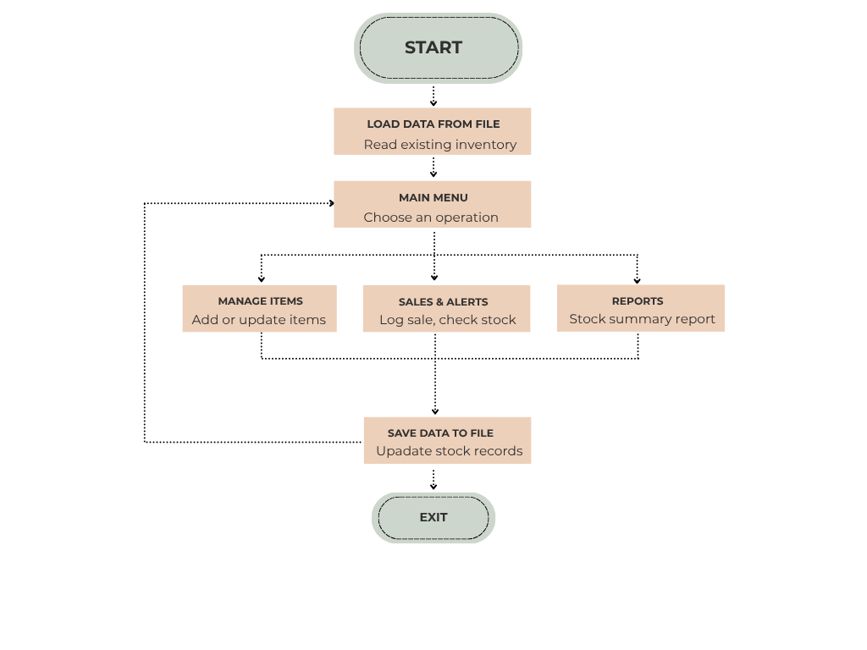
Fig 1: Program flow of the Inventory Stock Analysis System

6. Modularity Plan
The utility will be broken down into the following functions, each responsible for a single, well-defined task:
- load_data() — reads inventory data from the file at program start
- save_data() — writes the current inventory back to the file
- add_item() — adds a new item to the inventory
- update_stock() — updates quantity when stock is purchased or sold
- record_sale() — logs a sale transaction and reduces stock accordingly
- check_restock_alert() — flags items whose quantity has fallen below the threshold
- generate_summary() — uses NumPy/Pandas to compute and display stock statistics
- main() — displays the menu and routes user choices to the functions above

